**UNIVERSITY NETWORK DESIGN**

Submitted in partial fulfillment of the requirements for the award of degree of

BE-CSE (Computer Science Engineering) in Chandigarh University batch

(2018-2022)

**BACHELOR OF ENGINEERING**

**IN**

**COMPUTER SCIENCE & ENGINEERING**



**Submitted to: Mam JASMEET KAUR**

**PROJECT MENTOR: Sir INDERJEET SINGH**

**Submitted By**: ANIL THAKUR (18BCS3150)

PRITI PANDEY (18BCS3290)

ANIKET SINGH (18BCS3155)

KASHISH KUMAR (18BCS3171)

**DEPARTMENT OF COMPUTER SCIENCE & ENGINEERING**

**Chandigarh University, Gharuan**

**SECOND PROGRESS REPORT**

**IMPLEMENTATION:**

As mentioned in the first progress report 40% implementation work have been submitted including the:

* ISP network
* Admin block
* Administrative block

Now in the second progress report rest of the module implementation will be shown.

**1.. DEPARTMENT:**

A) CSE DEPARTMENT:

The network assigned to this department is 192.168.6.0

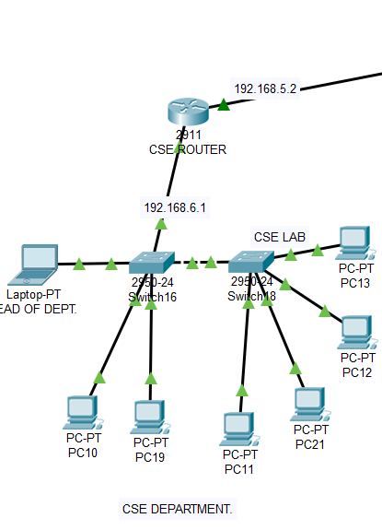

B) ELECTRICAL DEPARTMENT:

The network assigned to this department is 192.168.7.0

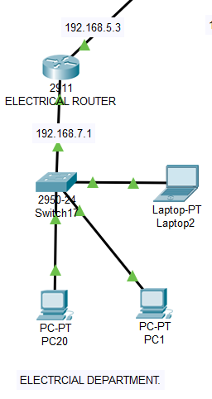

C) MECHANICAL DEPARTMENT:

The network assigned to this department is 192.168.8.0

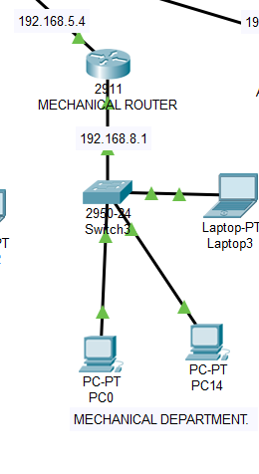

D) AERONAUTICAL DEPARTMENT:

The network assigned to this department is 192.168.13.0

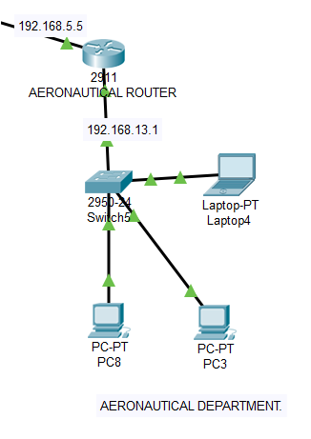

E) CIVIL DEPARTMENT:

The network assigned to this department is 192.168.14.0

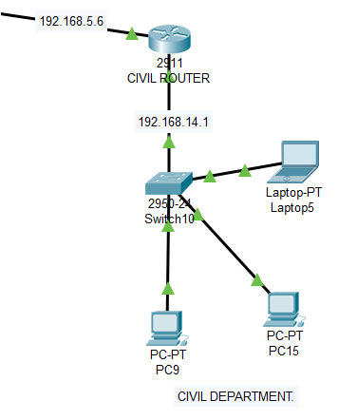

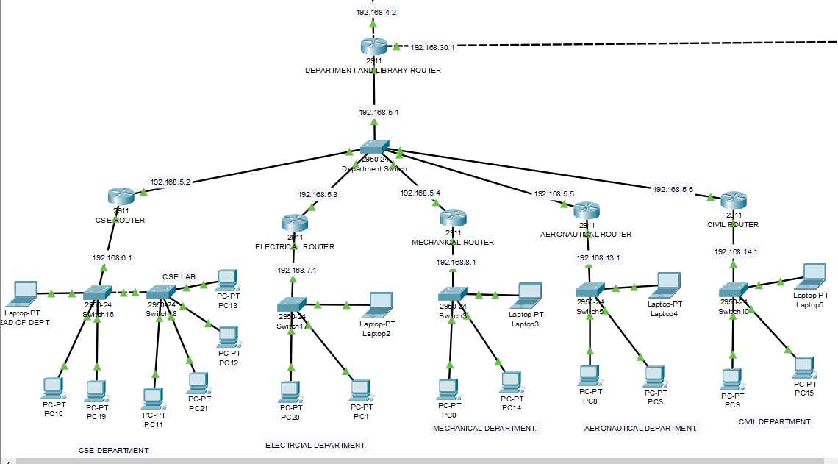

This is the complete snap of department module whose network is 192.168.5.0. Its router is connected to the admin router with network 192.168.4.0. A switch is used to connect the router of all the departments by assigning them different networks. The department router is acting as the ip pool for all the specific departments.

**2.. LIBRARY**

Its network is 192.168.20.0. its router is connected to the department router.

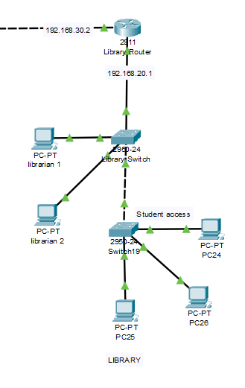

**3.. GUEST ROOM**

Its router is connected to hostel router and has network 192.168.40.0.

The network for point g0/1 of guest router is 192.168.50.0. Also, WIFI services with name “guest” has also been provided. PASSWORD is guest123.

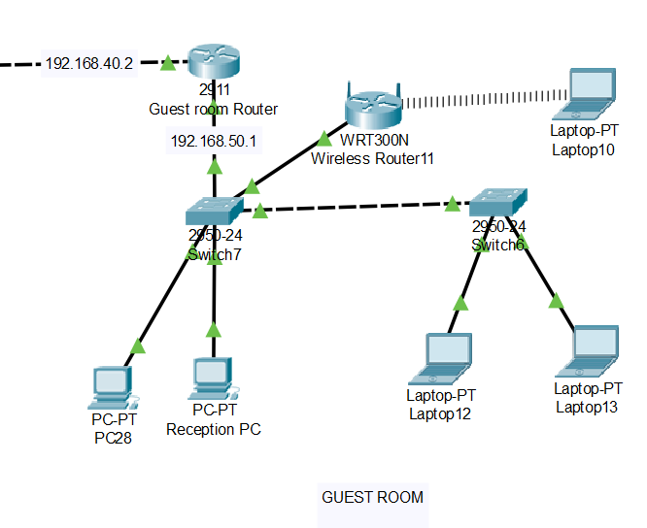

**4.. HOSTEL**

A) GIRLS HOSTEL

There are two blocks in girls’ hostel with network 192.168.12.0:

* GIRLS HOSTEL-A

WIFI name “girls-a” PASSWORD – girlsa123

* GIRLS HOSTEL-B

WIFI name “girls-b” PASSWORD – girlsb123

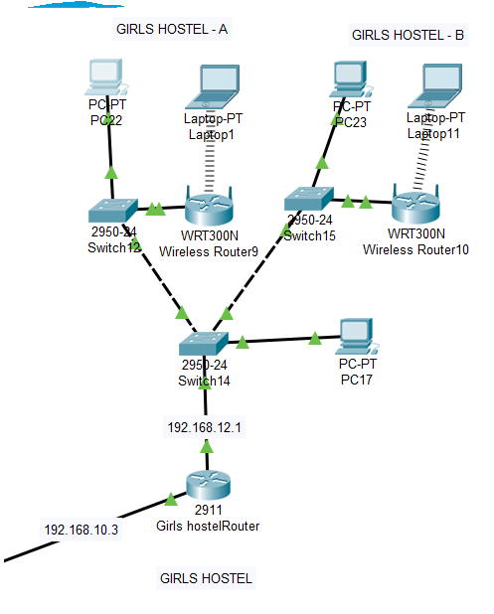

B) BOYS HOSTEL

There are three blocks in boys’ hostel with network 192.168.11.0

* BOYS HOSTEL-A

WIFI name “boys-a” PASSWORD – boysa123

* BOYS HOSTEL-B

WIFI name “boys-b” PASSWORD – boysb123

* BOYS HOSTEL-C

WIFI name “boys-c” PASSWORD – boysc123

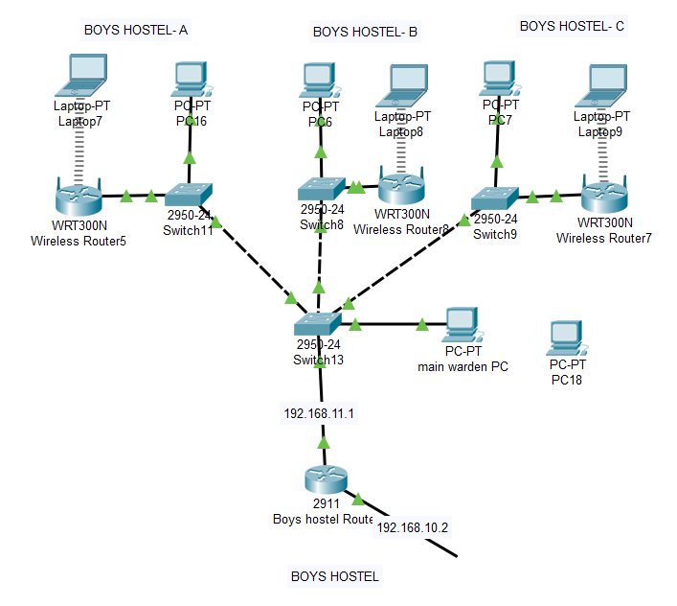

As a whole hostel snap is attached below which has a network 192.168.10.0

And the hostel router acts as the IP pool for DHCP IP provider.

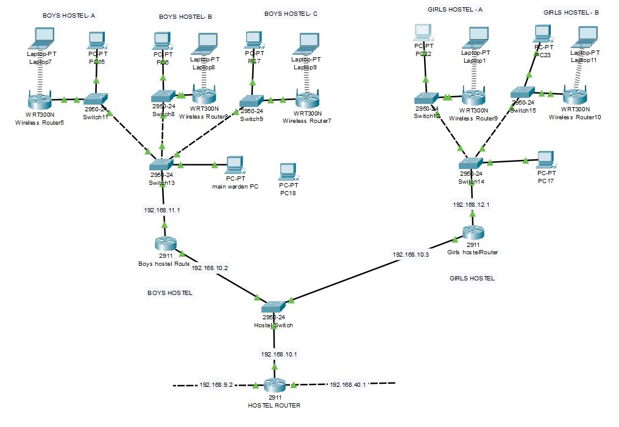

**5.. ADMINISTRATIVE BLOCK**

Few changes have been made in administrative module i.e. providing WIFI with name “admin” and PASSWORD- admin123.

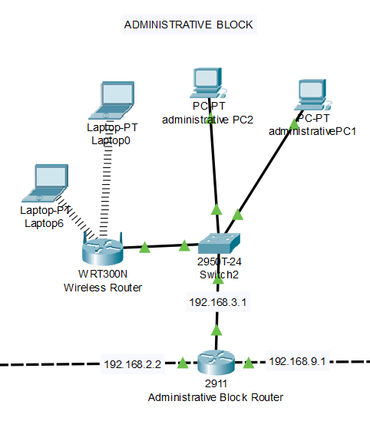

**OUTPUT:**

In this section we will show that if the pcs from various module are able connect to each other or not by using the ping function.

1. In this PC22 is girls-a hostel PC which can be seen connected to PC7 which is boys-c hostel PC.

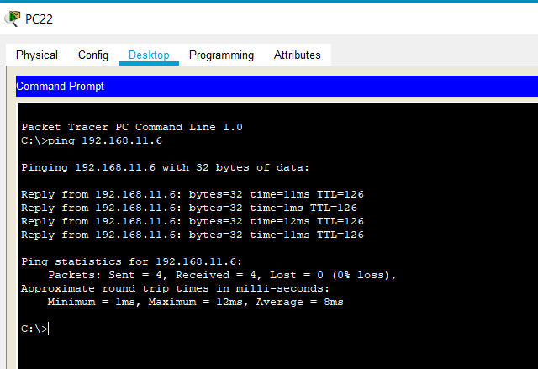

1. In this PC2 is administrative blocks PC which can be seen connected to PC9 which is civil department PC.

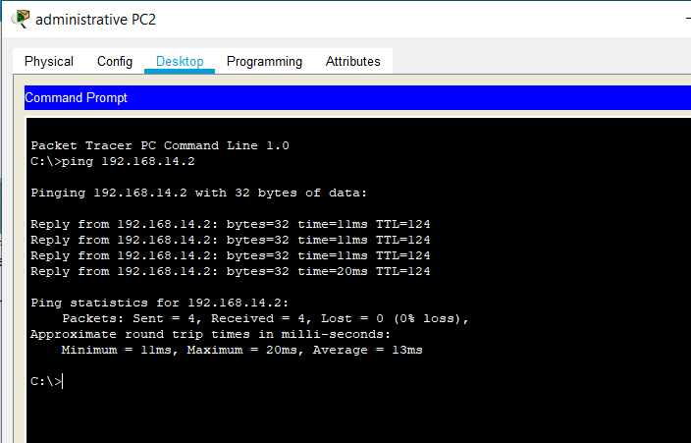Now we will see if the PC or laptops can access internet or not.

1. PC25 which is in library module can access internet.

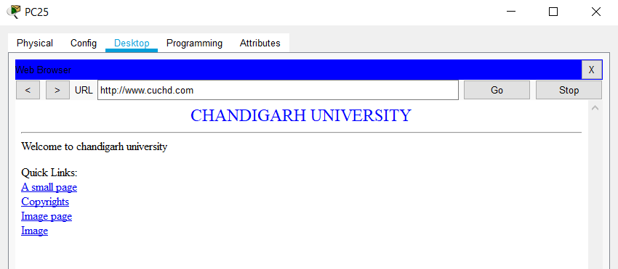

1. Laptop11 which is in girls-b hostel accessing through WIFI connectivity can access internet.

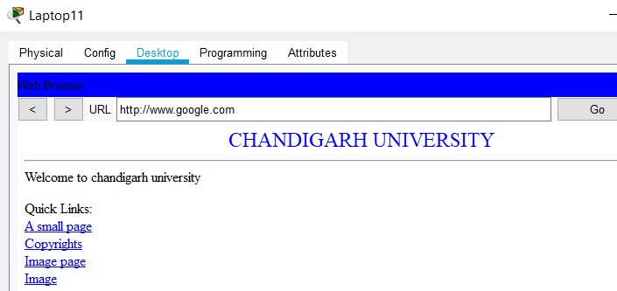

1. PC21 which is in CSE department can access internet.

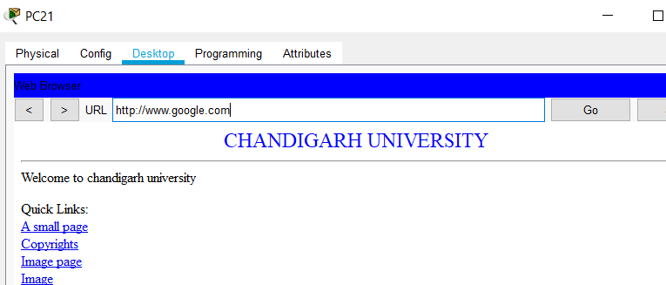

**OVERALL VIEW OF THE UNIVERSITY NETWORK:**

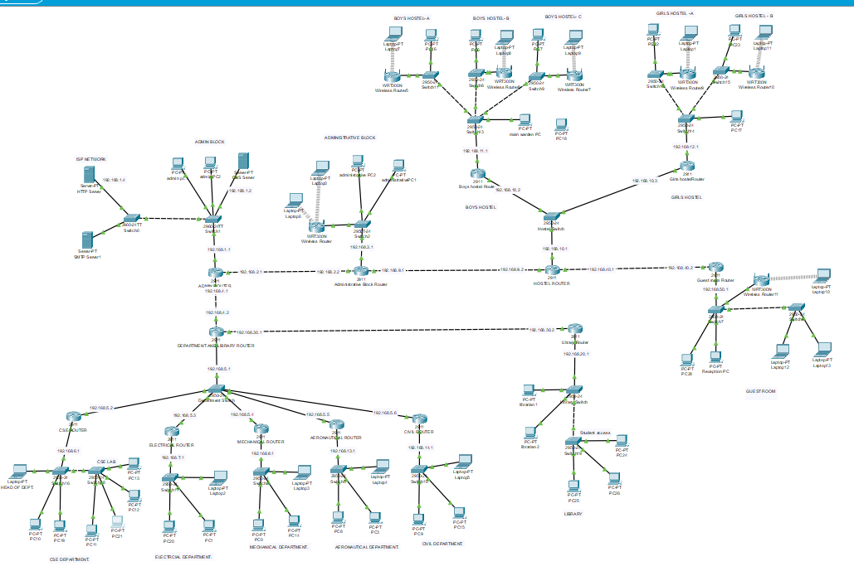

**APPLICATION OF PROJECT:**

The project is successfully implemented. It has six modules as defined in first progress report which combines to form the campus network. Every PC or laptop are connected to each other through routers and switches. Also, WIFI has been provided as necessity. WIFI have been provided with names and passwords so that no other department can access it freely.

The project finds its application in setting up of university network or any other office network with some module changes.

Although not very complicated structure has been provided to the network, we have kept it simple with the use of only few protocols.

It can be made complex and more fruitful by adding more protocols and features.

**TEAM WORK:**

All the members of the team have contributed their 100% in the project implementation as well as the documentation work of the project.

Work done by each member is as follows:

1. ANIL THAKUR: basic layout of the network and guest module design
2. KASHISH KUMAR: hostel and library module
3. ANIKET SINGH: department module
4. PRITI PANDEY: implementation of DHCP, SMTP and HTTP protocols and other IP address related work on command line.

The documentation work was equally carried out by all the members of the groups and at last every part of the document was compiled into a single piece of document.

**…………...END……………**